GitHub Documentation

Q1. Configure password less authentication in the repo’s.

Q2. Disable the forking in your repository **hu_devops_19_<employee_id>.**

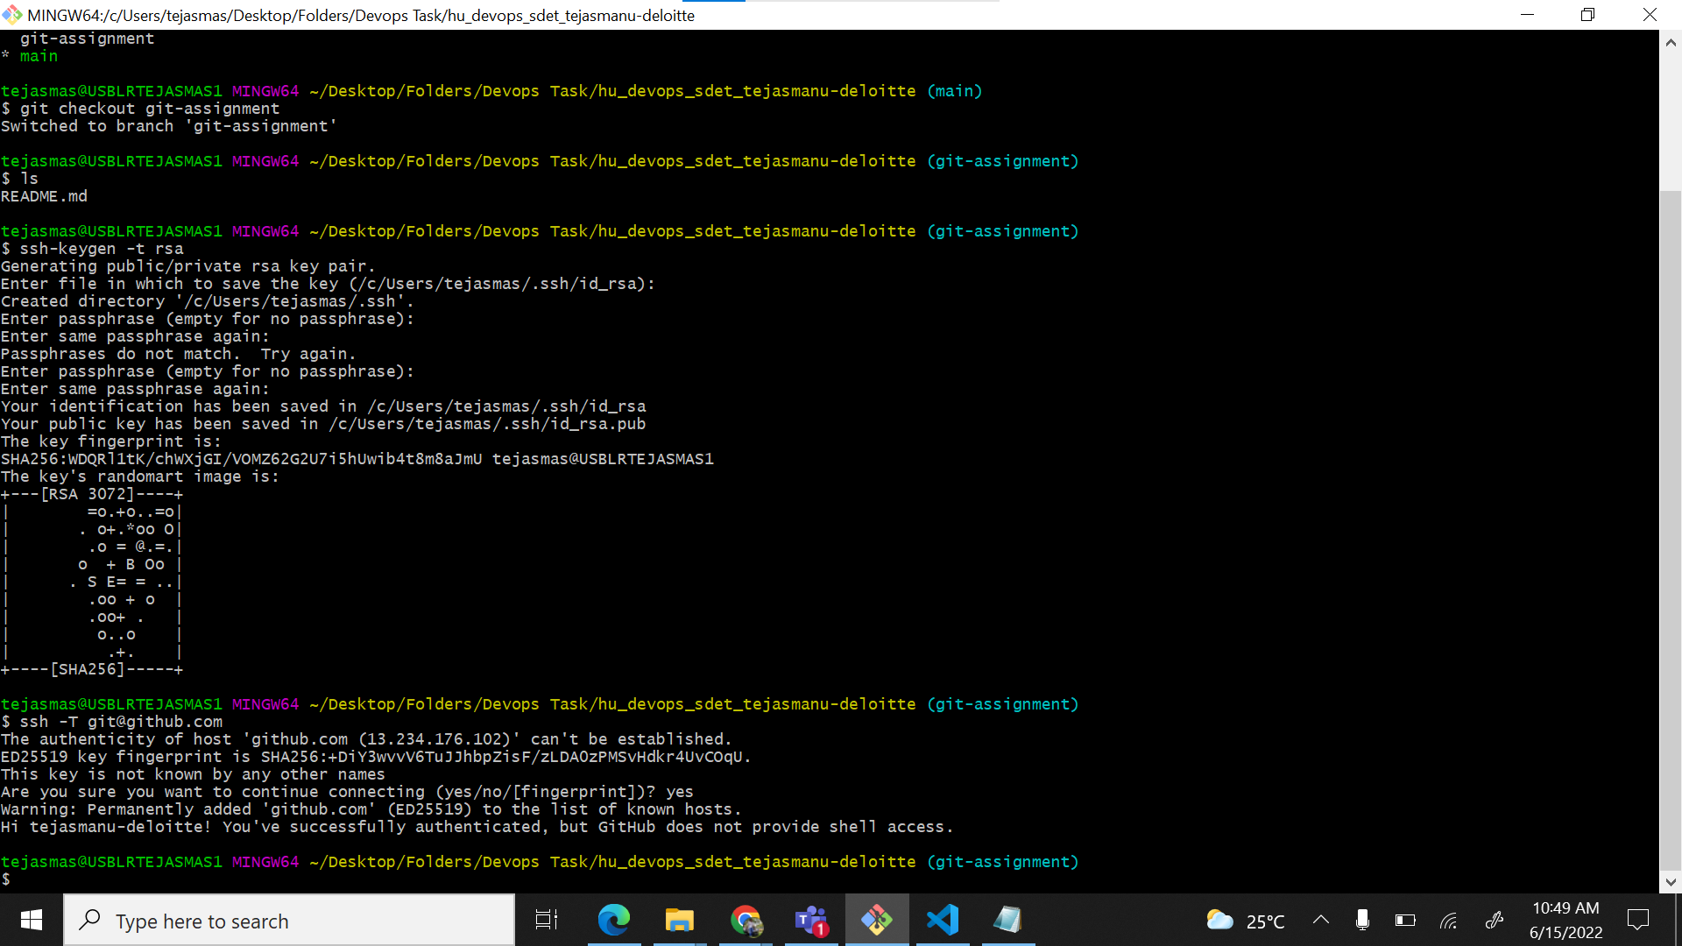

Q3. Clone the repo **hu_devops_19_<employee_id>**to your localhost.

Q4. Create a branch name **git-assignment** and start working on it, for all track assignments  all documents and code should be put on this branch.

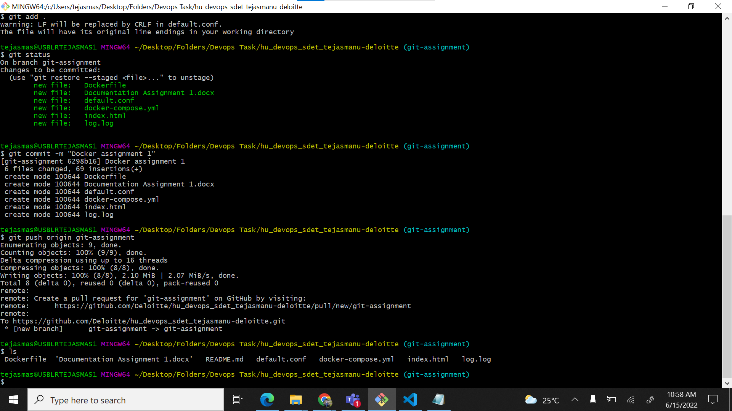

Q5. Create a file named secrets that should have your gitlab username and password, this file should not reflect in git console while you push to git repository.

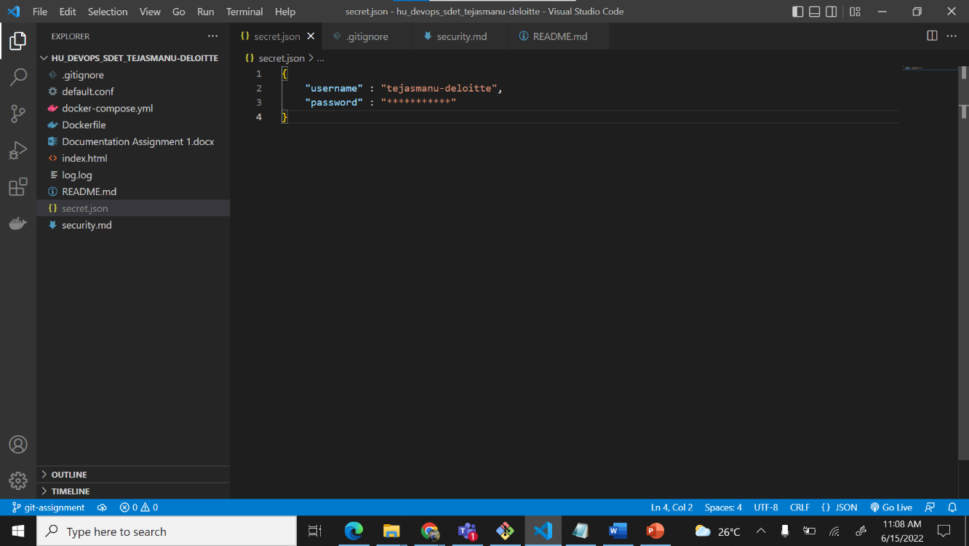

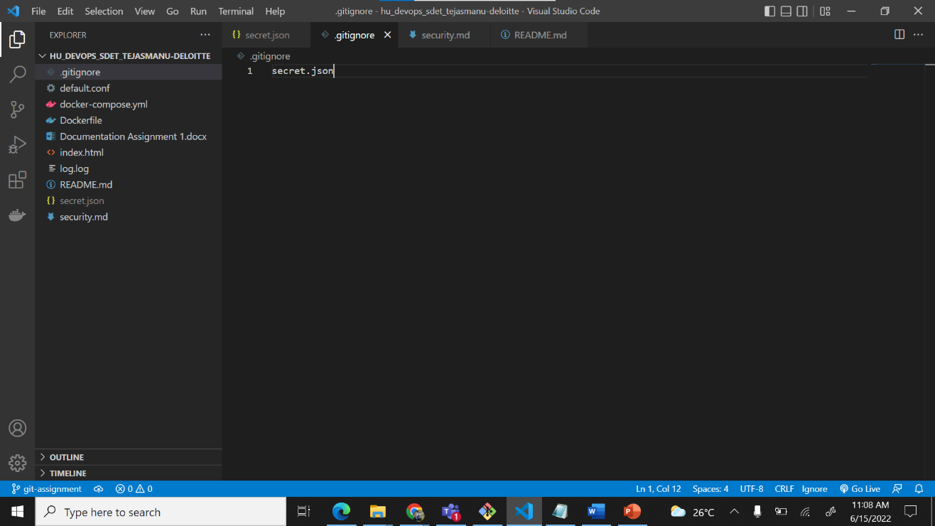

Q6. Create a security.md file and enter the information how above secret file was handled.

Q7. Create the document of the complete process in a file name README.md and push this file to the same branch.

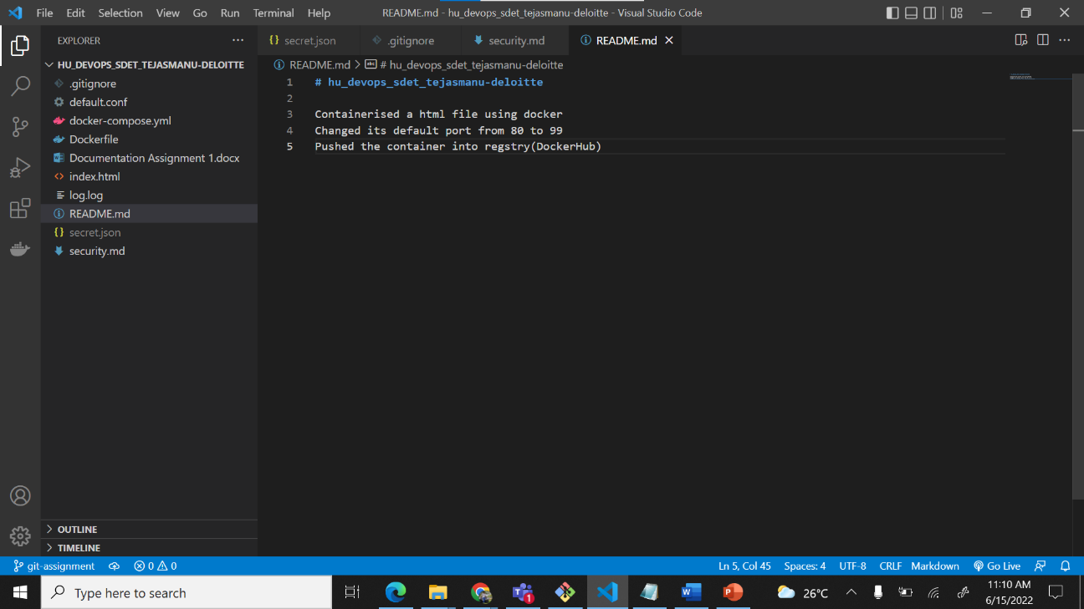

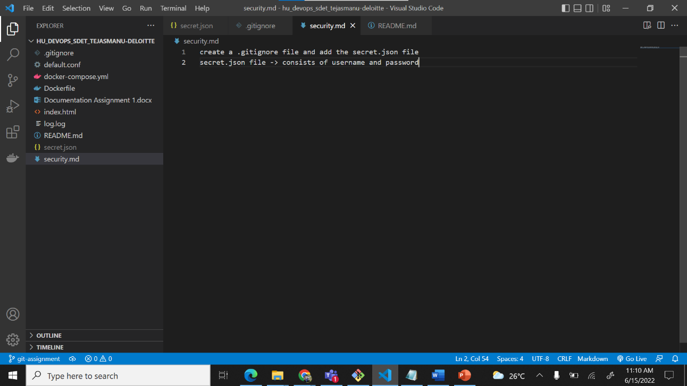

Q8. Raise the PR of this branch and send it to your track leads.

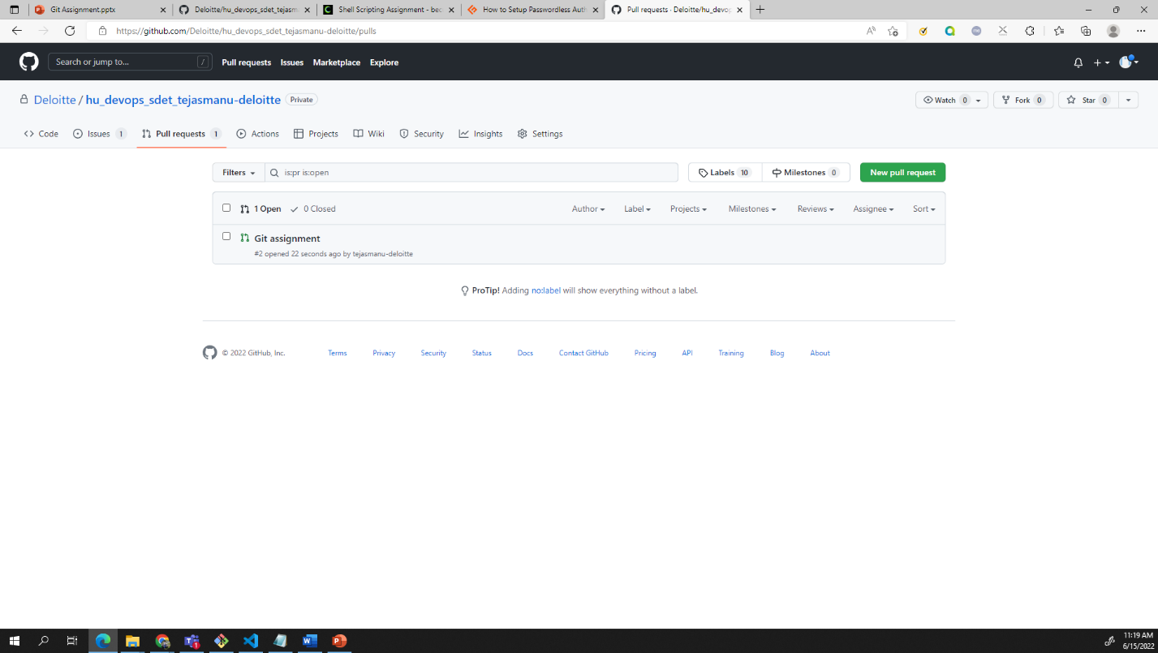

Q11. Once you have committed the changes create some more changes and push them, Take the screen shot of you commit history and paste them in your document.

